**Here’s a basic example of a 3-tier web application using Docker, Kubernetes, and Terraform for infrastructure as a code.**

**This example consists of three tiers: frontend, backend, and database.**

**1.Frontend: A simple web application serving as the user interface.**

**2.Backend: An Api service that interacts with the database.**

**3.Database: A database to store data.**

**Python Scripts:**

Frontend/app.py:

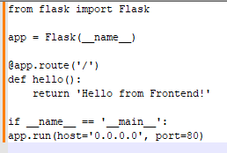

Backend/server.py:

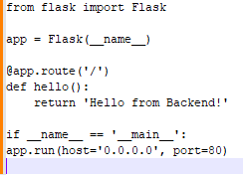]

Frontend/Dockerfile:

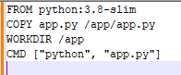

Backend/Dockerfile:

**Kubernetes Deployments:**

Frontend-Deployment:

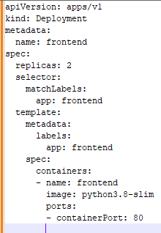

Backend-Deployment:

Database Deployment:

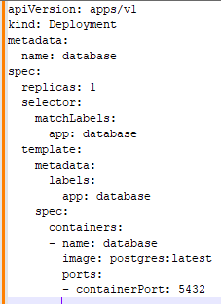

Kubernetes Services:

Frontend Service:

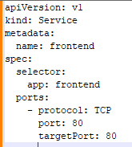

Backend Service:

Database Service:

**Deploy with Terraform:**

Main.tf

